**Lab 4 – *Decision structures and multiple functions* (100 pts)**

**Objectives:**

The objectives of this lab exercise are to:

1. Create a flowchart:
   1. The flowchart will assist you designing the Python solution for the shipping charges problem identified in Chapter 4, located on page 168 in the Programming and Logic Design textbook.

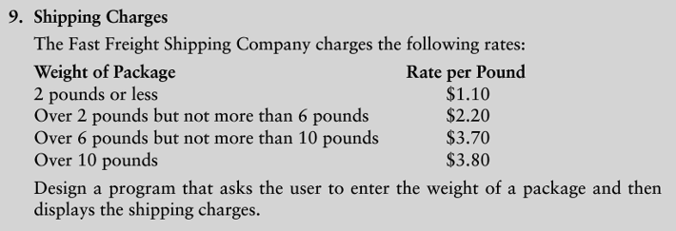

* 1. Refer to the flowchart symbols.
  2. Include the use of decision structures.
  3. The Python solution must include main and other functions that are needed to solve this problem. Refer to Chapter 3 “Modularizing Programs with Functions” in the Python 3 Language Companion for the textbook.
  4. Avoid global variables in your solution.
  5. Use Microsoft Visio or any other flowcharting tool. There are many free apps available for mobile devices.

1. Write the out the pseudocode needed to solve this problem.
2. Solve the problem through a Python programming solution.
   1. Use a modular approach with more than one function.

**Discussion:** Run the Python program a minimum of three times to test your program.

**Specifications:**

* **(25 pts) - Flow chart**
  1. Correctly use the flowchart symbols in your flowchart.
  2. Include the start and end of the program in your flowchart.
  3. Include arrows to show the flow through the program.
* **(25 pts) – Pseudocode**
  1. Write the pseudocode to solve the shipping cost problem.
  2. You may write the pseudocode first or create the flowchart, it is up to you.
* **(50 pts)** **– Python Program**

Using a Python programming environment of your choice, create a Python source code file(i.e., .py) file.

#=============================================================

# Course-Lab: CS104 -- Lab-04 – Shipping Charges

# Filename: Lab4_ShippingCharges.py

# Author: <Your name>

# Purpose: Demonstrate basic Python programming skills by designing, and developing a

# programming solution that utilizes multiple functions for calculating shipping

# charges. Four shipping rates have been pre-defined based on package weight.

#=============================================================

**Deliverable(s):**

Hand in the source code listings for both of the programs listed above as well as the outputs from running them. Test the program, at least, three times inputting different values each time. Capture the output and paste into your Python program after the Python code. Add triple sets of quotes before the output along with triple sets of quotes after the end of the output. Make sure to use only double quotes or single quotes, and do not mix them together.